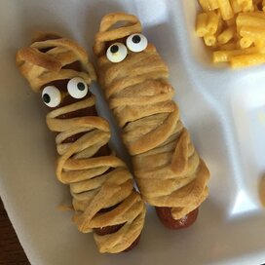

**Hot Dog Mummies**

**Ingredients:**

8 hot dogs

1 (8 ounce) package refrigerated crescent rolls

(such as Pillsbury Grands! Big and Flaky)

1 teaspoon yellow mustard, or as needed (Optional)

**Directions:**

1. Preheat oven to 350 degrees F (175 degrees C).
2. Place hot dogs in a saucepan and cover with water; bring to a boil. Reduce heat to medium-low and simmer until warmed through, about 5 minutes. Drain
3. Roll crescent dough onto a work surface; tear into 8 pieces. Roll 1-piece dough around each hot dog, creating the look of a mummy. Place dots of mustard on the top of each for the eyes, nose, and mouth. Arrange hot dogs on the baking sheet.
4. Bake in the preheated oven until crescent dough is golden brown and flaky, about 10 minutes.

**Cook’s Note:**

You can change the mustard features to ketchup or something else or you could add hair. It’s your preference.

**Nutrition Facts (Per Serving)**

Calories 248 Prep: 10 minutes

Protein 7.2 g (14% DV) Cook: 15 minutes

Carbohydrates 11.8 g (4% DV) Total: 25 minutes

Fat 18.5 g (28% DV) Servings: 8

Cholesterol 22.5 mg (8% DV) Yields: 8 mummies

Sodium 731.3 mg (29% DV)